***A Mini Project Report on***

**PyTech**

**S.E. I.T Engineering.**

**Submitted By**

**Athul Nair 20104048**

**Devanshu Mahapatra 20104036**

**Subhashish Mahapatra 20104049**

**Nishank Jain 20104046**

**Under the guidance of**

**Prof. Rajashri Chaudhari**

**Department of Information Technology**

**A.P. SHAH INSTITUTE OF TECHNOLOGY**

G.B. Road, Kasarvadali, Thane (W), Mumbai – 400615

**Academic Year – 2021-22**

**CERTIFICATE**

This to certify that the **Mini Project report on PyTech** has been submitted by **Athul Nair** (2104048) , **Devanshu Mahapatra** (20104036), **Nishank Jain** (20104046) and **Subhashish Mahapatra** (20104049) who are a Bonafide students of A. P. Shah Institute of Technology, Thane, Mumbai, as a partial fulfilment of the requirement for the degree in Information Technology, during the academic year 2021-2022 in the satisfactory manner as per the curriculum laid down by University of Mumbai.

**Mr. Rajashri Chaudhari**

**Guide**

**Prof. Kiran Deshpande Dr. Uttam D Kolekar**

**Head Dept. of Information Technology Principal**

**External Examiner(s):**

**1.**

**2.**

Place: A.P. Shah Institute Of Technology, Thane

Date:

**ACKNOWLEDGEMENT**

This project would not have come to fruition without the invaluable help of our guide Mrs. Rajashri Chaudhari Expressing gratitude towards our HoD, **Prof. Kiran Deshpande**, and the Department of Information Technology for providing us with the opportunity as well as the support required to pursue this project. And also, for giving us his valuable suggestions and ideas when we were in need of them. We would also like to thank our peers for their helpful suggestions.

**TABLE OF CONTENTS**

1. Introduction. ..................................................................................................... 1

1.1 Purpose ............................................................................................................. 1

1.2 Objectives. ........................................................................................................ 2

1.3 Scope ................................................................................................................ 3

2. Problem Definition ........................................................................................... 4

3. Proposed System .............................................................................................. 5

3.1 Features and Functionality ............................................................................... 5-6

4. Project Outcomes ............................................................................................. 7

5. Software Requirements .................................................................................... 7

6. Project Design .................................................................................................. 8-9

7. Project Implementation .................................................................................... 10-

8. Conclusion ........................................................................................................ 11

References ......................................................................................................... 12

**Chapter 1**

**Introduction**

This project ‘PyTech’ is developed in Python language. It uses Django web framework in the development of a technical website. The main goal of our project is to create a real world eCommerce application. All the functionalities of this website is purely based on python.

**1.1 Purpose:**

The purpose of the website is to provide the user various type of application by fulfilling their requirements, so that their valuable data/information can be stored for a longer period with easy accessing and manipulation of the same. The required software and hardware are easily available and easy to work with.

Our project allows people to buy and sell physical goods, services, and products digitally over the internet. Through an e-commerce website, a business can process orders, accept payment and manage logistics, and provide customer service.

To help business owners to Create an online store which helps them to promote their products to a larger customer base with ease & without worrying about budget constraints.

It also makes it easier for customers as Opening a virtual shop over a website makes it easy for shoppers to reach the business and shop from them instantly.

* 1. **Objectives:**

The main objective of the Pytech is to create high-end visual webpage by using Django. The project is built at user end and thus, the administrator (superuser) have a guaranteed access. The objectives of project are:

* To design a website for the purpose of viewing products and for purchasing them.
* To ensure accurate and bug free shopping experience.
* To generate bill for the products purchased.
* To make user account secure by implementing Two-Factor verification.
* To store the data of order placed by the buyer in systematic way.

**1.3 Scope**

Our project aims at Administration process automation, i.e., we have tried to computerize various processes of our project.

* This website provides products accessible to every user.
* In this busy world, the products in this website can be useful
* to make life stress free and make various work easier.
* The applications that can be purchased from this website saves time and improve workflow.
* In the future, we will be implementing downloadable products so that users can enjoy their purchase instantly.
* To utilize resources in an efficient manner by increasing their productivity through automation.
* The system generates types of application that can be used for daily purposes.
* Be easy to understand by the user and the seller
* Have a good user interface
* Be expandable

# Chapter 2

**Problem Definition**

* In today world people are busy and need a faster life
* Due to which people are keen in searching application to make their work faster and easier
* Searching various application at various different website make them difficult to find
* And searching for application in various website leads to chances of viruses in system.
* Thus, by seeing this we have introduced several applications in one place at our website
* It also includes games and eBooks which also contribute in entertainment
* This application is paid and account of user in our website is secure due to two factor verification
* So we decided to develop a website called Pytech which contain various application at one place which has a proper billing system which ensures that your ordered item is safe and secured

# Chapter 3

**3.1 Proposed System:**

We resolve all the disadvantages of existing system in our proposed system. Time will be saved with no chance of getting error.

* System needs to store information about the customers.
* System needs to store and display all products in a dedicated manner
* System needs to ensure proper validation and authentication of user.
* System needs to update and delete the products as well as the customer’s records.
* It also needs a updated security system to prevent data leak.

**3.2 Features and Functionality:**

* Admin Accounts to control the access and maintain security
* Accuracy in search.
* It provides variety of applications at one place.
* Decrease the load of the person involve in existing manual system.
* Access of any information individually.
* Anyone can play games and use various other applications free of charge.
* The UI is user friendly and interactive, with an emphasis for being beginner friendly.
* Users can view the products, add them to cart and checkout as usual. They can also register themselves and get a confirmation mail back.
* It is highly secure and uses Two Factor Authentication.
* It provides confirmation mail for ordered items.
* It also contains rating section where customers can rate their product.

# Chapter 4

**Project Outcome:**

* To gain access to the system in a safe way.
* User will be able to Register & Login. If in case, user forgets their password, then will be able to change their password as well.
* User will be able to access the Store Page.
* User will be able to search for the products , purchase the products and review them.
* User will able to get total amount accurately at the time of billing.
* The customer will have an interactive and well-designed GUI for online store
* User will also be able to add or remove the items as per their requirements.
* User will get a confirmation email during time of registration as well as after order confirmation.

# Chapter 5

**System Requirements:**

**Software Requirements:**

* Operating System: - Mac OS X and above , Windows 7 and above.
* Language: - Python, Django
* Database:- SQLITE3, PostgreSQL

**Hardware Requirement: -**

* Ram:- 200 Mb and above
* Hard Disk: - 20GB
* Processor :- Intel i3 and above / M1 and above

# Chapter 6

**Project Design :**

In this phase, a logical system is built which fulfils the given requirements. Design phase of software development deals with transforming the client’s requirements into a logically working system. Normally, design is performed in the following in the following two steps:

1. Primary Design Phase**:** In this phase, the system is designed at block level. The blocks are created on the basis of analysis done in the problem identification phase. Different blocks are created for different functions emphasis is put on minimising the information flow between blocks. Thus, all activities which require more interaction are kept in one block.
2. Secondary Design Phase: In the secondary phase the detailed design of every block is performed.

The general tasks involved in the design process are the following:

1. Design various blocks for overall system processes.
2. Design smaller, compact and workable modules in each block.
3. Design various database structures.
4. Specify details of programs to achieve desired functionality.
5. Design the form of inputs, and outputs of the system.
6. Perform documentation of the design.
7. System reviews.

# Chapter 6

**Project Implementation :**

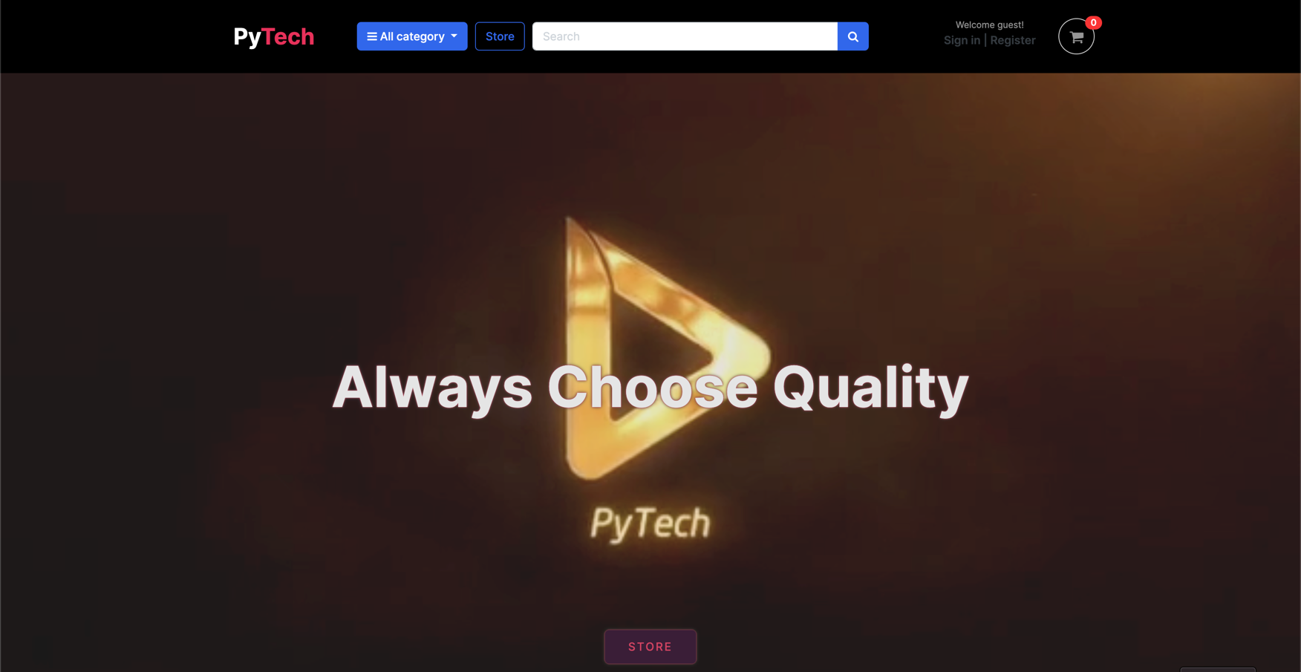  
User Interface Design is concerned with the dialogue between a user and the computer. It is concerned with everything from starting the system or logging into the system to the eventually presentation of desired inputs and outputs

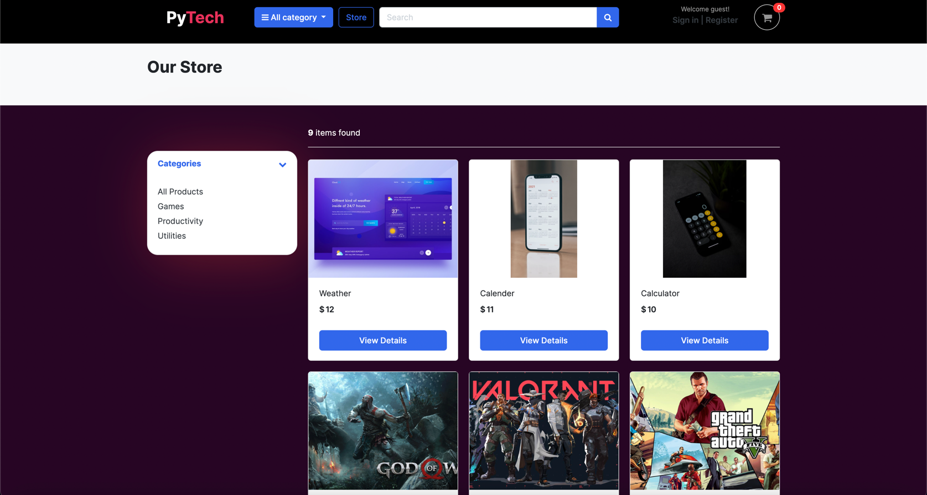**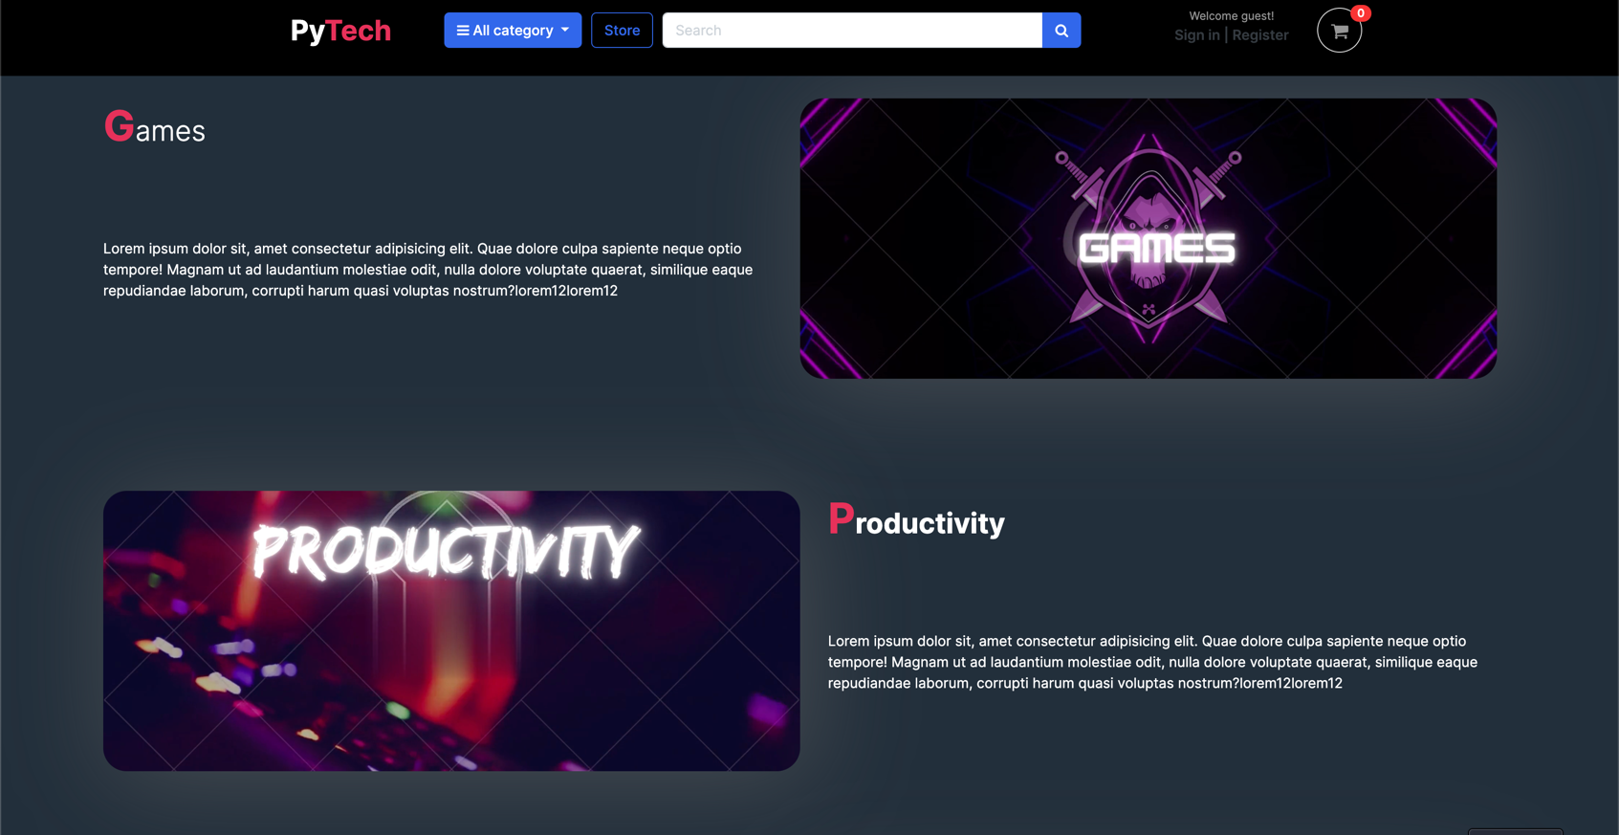HOME PAGE:**

**STORE PAGE:**

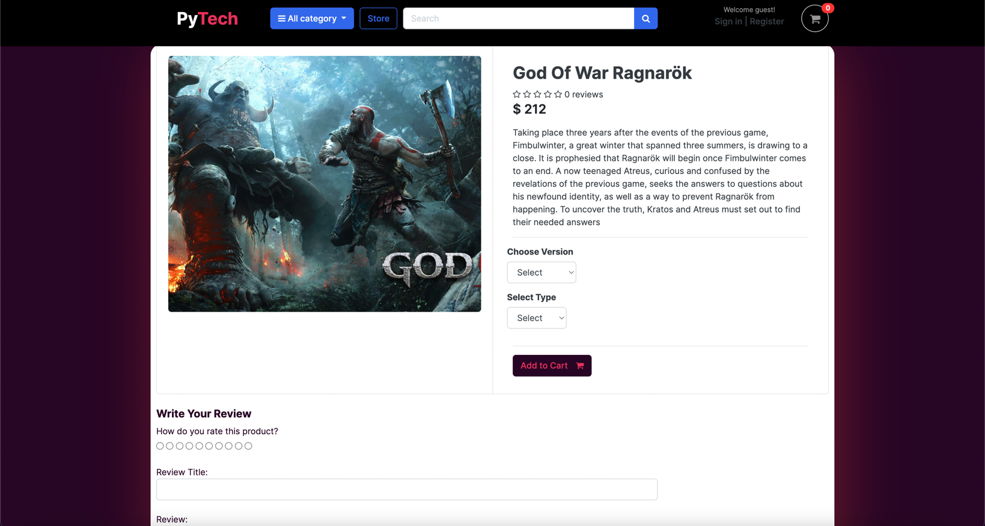**PRODUCT DETAILS PAGE:**

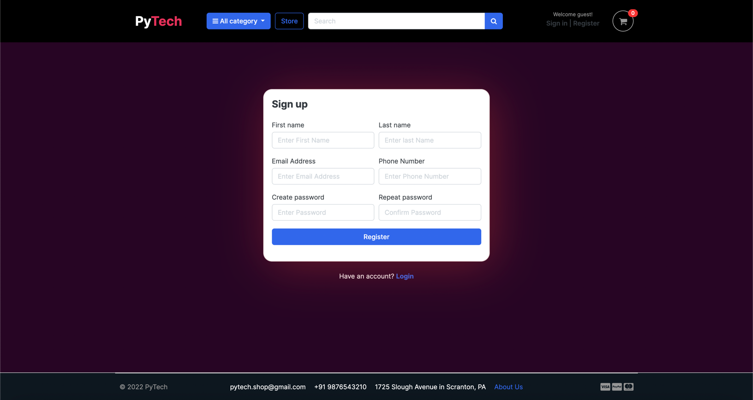**REGISTER PAGE:**

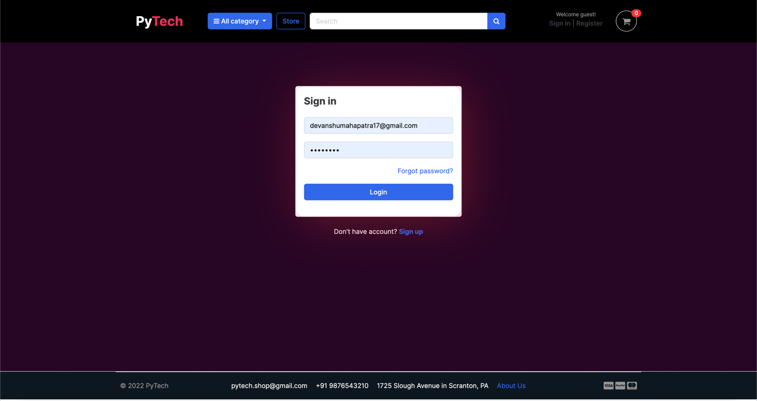**LOG IN PAGE:**

**CART PAGE:**

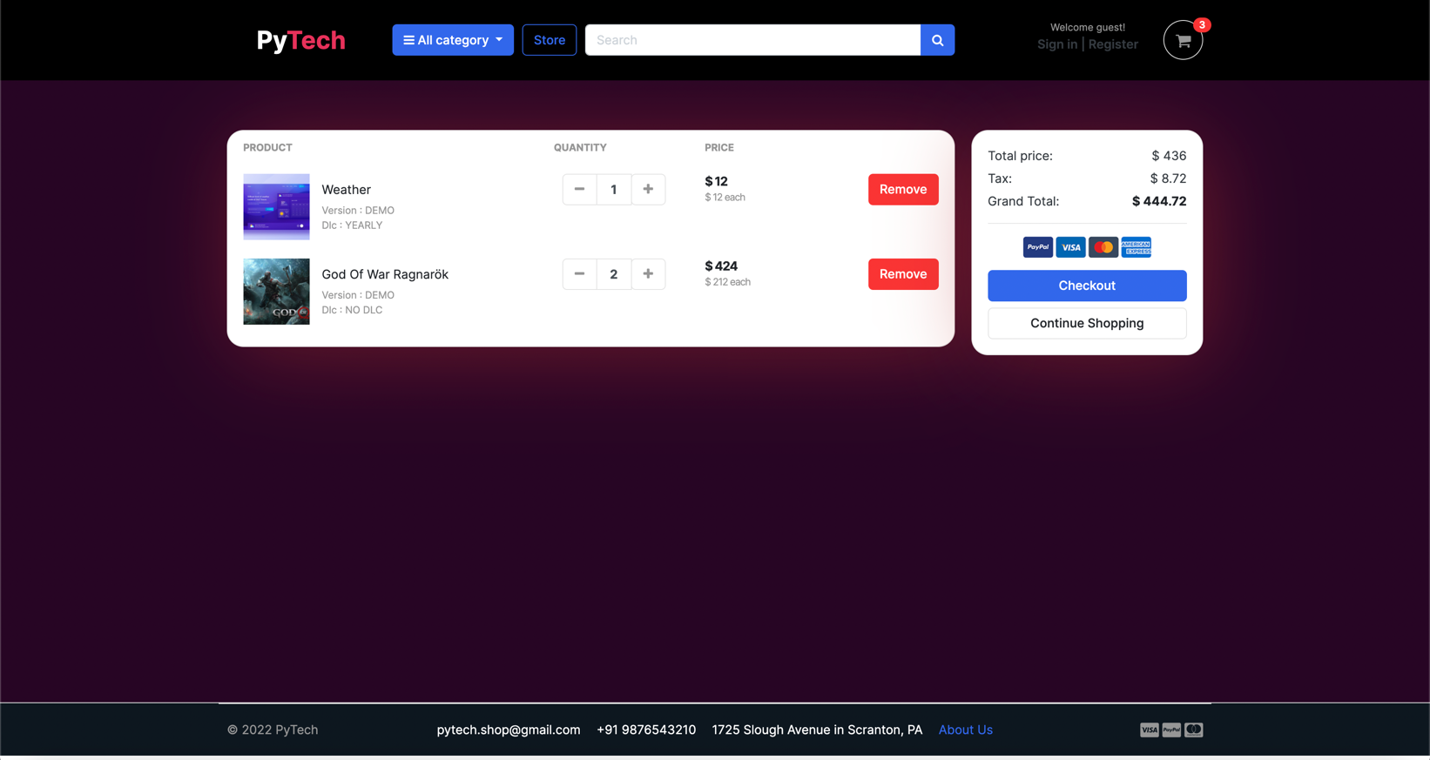

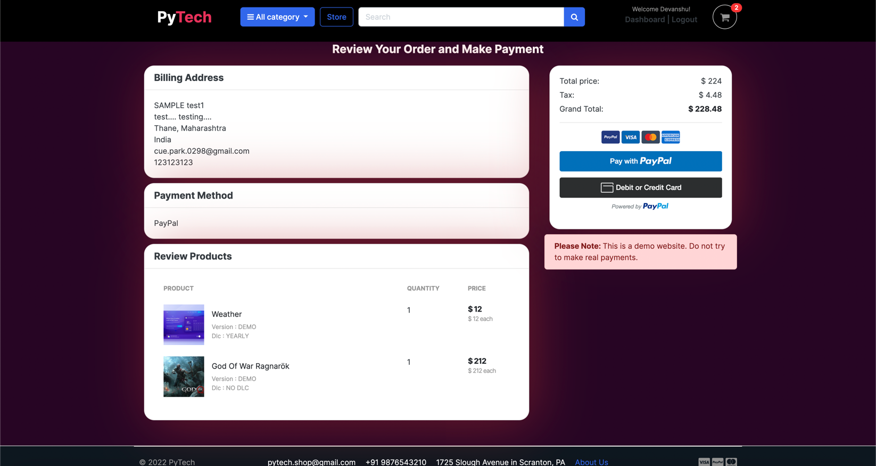CHECKOUT PAGE:

# Chapter 7

**Project Scheduling Template**

|  |  |  |
| --- | --- | --- |
| **Group Member** | **Time duration** | **Work to be done** |
| DEVANSHU MAHAPATRA  SUBHASHISH MAHAPATRA  ATHUL NAIR  NISHANK JAIN | 4th week of January | Implementing 1st module/ functionality   (Designing the Home page, login page and the store page. User can login with security verification and will be able to enter to the store page) |
| 1st week of February | Testing 1st module    (Store menu: This will consist of the Navigation bar and the product details where user will get the following options:   * All Product Category * Store Page Button Functionality * Search Bar * User Registration/Login * Cart Functionality |
| 2nd week of March | Implementing 2nd module / Functionality  (Designing next page / functionality: Here we have integrated the Paypal API for payment functionality and display the information of Customer’s ~ Cart, Order Item, Bill of Ordered item, Email Confirmation, etc.) |
| 4th week of March | Implementing 3rd module / Functionality  (Designing Final page / functionality: Here we have designed and implemented User Dashboard, Customer rating page and final front end designing functionalities) |

# 

**Chapter 8:**

**Conclusion:**

Our project satisfies the need to manage their project work. Several user-friendly coding has also adopted. This package shall prove to be a powerful package in satisfying all the requirements of the College with an integrated library.

* Made statement of the aims and objectives of the project.
* The description of Purpose, Scope, and applicability.
* We define the problem on which we are working in the project.
* We describe the requirement Specifications of the system and the actions that can be done on these things.
* We understand the problem domain and produce a model of the system, which describes operations that can be performed on the system.
* We included features and operations in detail, including screen layouts.
* We designed user interface and security issues related to system.
* Finally, the system is tested and implemented.

**References**

1. Udemy Course: <https://www.udemy.com/course/django-ecommerce-project-based-course-python-django-web-development/>
2. Django Course from Coursera provided by University of Michigan: <https://www.coursera.org/specializations/django?>
3. Django Official Documentation: <https://docs.djangoproject.com/en/4.0/>